# Question

The YOLO model divides an image into a 19×19 grid, with each grid cell generating 5 bounding boxes. This results in a total of 19 × 19 × 5 = 1805 initial boxes. The yolo_filter_boxes function filters these boxes by calculating a combined score (box confidence × highest class probability) and retaining only those with a score above the threshold of 0.5. Consequently, 1783 boxes remain, indicating that 22 boxes were discarded for having scores below the threshold.

* Maximum: 1805 boxes (if all pass the threshold).
* Minimum: 0 boxes (if none pass the threshold).

# Question

Anchor boxes allow the model to detect objects of various shapes and sizes by predefining potential bounding boxes of multiple scales and aspect ratios. This approach helps in improving the detection accuracy, especially for images with multiple objects of different sizes, and reduces the complexity of the model by minimizing the need for the network to learn to predict size and aspect ratio for each object independently.

Method:

The sizes of anchor boxes are usually determined through a clustering approach on the training dataset, typically using k-means clustering. This method involves clustering ground truth bounding boxes to optimize for width and height by minimizing the Intersection over Union (IoU) loss, rather than traditional Euclidean distance. The number of clusters, k, is a tunable hyperparameter that depends on the diversity of object sizes in the dataset.

# Question

Figure 1 detected image

Figure 2 original

• Correctly Detected Objects: Traffic Light, Truck

• Incorrectly Detected Objects: there is no incorrect detection

• Undetected Objects: other traffic lights, long-distance car and bicycle

• Incorrect Bounding Boxes: there is no incorrect bounding boxes

## 

* Correctly Detected Objects: Traffic Light, Truck
* Incorrectly Detected Objects: there is no incorrect detection
* Undetected Objects: other traffic lights, long-distance car and bicycle
* 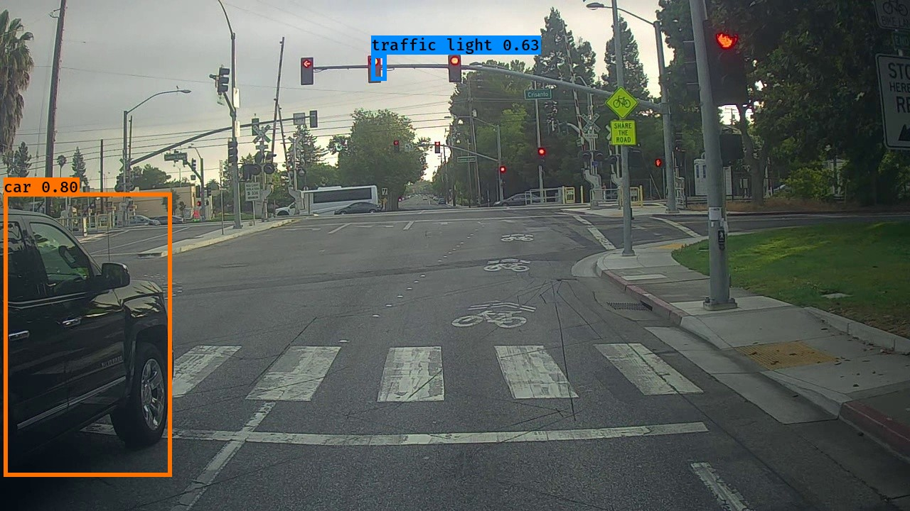A crosswalk with red lights

  Description automatically generatedIncorrect Bounding Boxes: there is no incorrect bounding boxes
* Correctly Detected Objects: car, traffic light
* Incorrectly Detected Objects: there is no incorrect detection
* Undetected Objects: : other traffic lights, one truck and other long-distance cars
* Incorrect Bounding Boxes there is no incorrect bounding boxes

# Question

Upon adjusting the max_boxes parameter in the YOLO model's evaluation settings, there were no changes observed in the output for the autonomous driving dataset images. This indicates that the original setting for max_boxes was likely sufficient, and the limit was not a constraining factor in the detection results.

In an effort to refine object detection capabilities, the score_threshold was adjusted from 0.6 to 0.3, while maintaining the original values for max_boxes and iou_threshold. This adjustment led to a noticeable improvement in the detection accuracy, as the model was able to identify additional object classes that were not detected with the higher threshold. This suggests that the original threshold was potentially too restrictive, omitting valid detections. The newly detected objects with the lowered threshold demonstrate the model's enhanced ability to recognize and classify a wider range of objects within the autonomous driving dataset.

IOU threshol:

Modifying the iou_threshold had no impact on detection results, suggesting the original setting was already optimal or that the dataset characteristics do not significantly affect IoU sensitivity in this model configuration.